EXPERIMENT 5:
PROGRAM CODE:
import numpy as np
import pandas as pd
import matplotlib.pyplot as plt

np.random.seed(24)

print("="*85)
print("1. SUCCESSFUL RFID/NFC DEVICE IDENTIFICATION & REGISTRATION")
print("="*85)
device_tags = [
("RFID-TAG-101", "Sensor Node Alpha", "Authenticated", "-65 dBm"),
("NFC-TAG-202", "Gateway Controller", "Authenticated", "-45 dBm"),
("RFID-TAG-303", "Actuator Unit Beta", "Authenticated", "-70 dBm")
]
df_tags = pd.DataFrame(device_tags, columns=["Device UID", "Description", "Authentication Status", "Signal Strength"])
print(df_tags.to_string(index=False))

print("\n" + "="*85)
print("2. MQTT MESSAGES & FOUR-LAYER IoE DATA FLOW SIMULATION")
print("="*85)
mqtt_messages = [
("Perception", "rfid/sensor/tag_101", "UID: RFID-101 | Status: Active | Temp: 24.5C"),
("Network", "iot/mqtt/broker/uplink", "Publish QoS 1 | Payload Size: 512 bytes"),
("Middleware", "nodered/flow/rule_engine", "Node-RED JSON Filter & Threshold Trigger Passed"),
("Application", "cloud/grafana/dashboard", "Grafana Time-Series Push Successful")
]
df_mqtt = pd.DataFrame(mqtt_messages, columns=["IoE Layer", "MQTT Topic", "Payload / Message Content"])
print(df_mqtt.to_string(index=False))

print("\n" + "="*85)
print("3. PERFORMANCE EVALUATION ACROSS FOUR LAYERS")
print("="*85)

layers = [
"Perception (RFID/NFC)",
"Network (MQTT Protocol)",
"Middleware (Node-RED)",
"Application (Cloud Dashboard)"
]

simulation_time = 120
packets_sent = 1200
packet_size = 512

parameters = {
"Perception (RFID/NFC)": {"pdr": 96.5, "delay": 25, "energy": 8, "throughput": 48},
"Network (MQTT Protocol)": {"pdr": 98.2, "delay": 42, "energy": 14, "throughput": 55},
"Middleware (Node-RED)": {"pdr": 97.8, "delay": 58, "energy": 22, "throughput": 50},
"Application (Cloud Dashboard)": {"pdr": 99.0, "delay": 85, "energy": 30, "throughput": 62}
}

results = []

for layer in layers:
p = parameters[layer]
pdr = np.clip(p["pdr"] + np.random.normal(0, 0.8), 85, 100)
delay = max(1, p["delay"] + np.random.normal(0, 2.0))
energy = max(1, p["energy"] + np.random.normal(0, 0.6))
throughput = max(1, p["throughput"] + np.random.normal(0, 1.0))
packets_received = round(packets_sent * pdr / 100)
results.append([layer, packets_sent, packets_received, round(pdr, 2), round(throughput, 2), round(delay, 2), round(energy, 2)])

df_perf = pd.DataFrame(results, columns=["IoE Layer", "Packets Sent", "Packets Received", "Packet Delivery Ratio (%)", "Throughput (kbps)", "Average Delay (ms)", "Energy Consumption (J)"])
print(df_perf.to_string(index=False))

best_pdr = df_perf.loc[df_perf["Packet Delivery Ratio (%)"].idxmax(), "IoE Layer"]
best_throughput = df_perf.loc[df_perf["Throughput (kbps)"].idxmax(), "IoE Layer"]
lowest_delay = df_perf.loc[df_perf["Average Delay (ms)"].idxmin(), "IoE Layer"]
lowest_energy = df_perf.loc[df_perf["Energy Consumption (J)"].idxmin(), "IoE Layer"]

print("\nPERFORMANCE SUMMARY")
print("-"*45)
print("Best PDR :", best_pdr)
print("Best Throughput :", best_throughput)
print("Lowest Delay :", lowest_delay)
print("Lowest Energy :", lowest_energy)

metrics = [
("Throughput (kbps)", "Throughput Comparison across 4-Layer IoE", "Throughput (kbps)"),
("Average Delay (ms)", "Average Delay Comparison across 4-Layer IoE", "Delay (ms)"),
("Packet Delivery Ratio (%)", "Packet Delivery Ratio across 4-Layer IoE", "PDR (%)"),
("Energy Consumption (J)", "Energy Consumption across 4-Layer IoE", "Energy (J)")
]

for column, title, ylabel in metrics:
plt.figure(figsize=(9, 5))
plt.bar(df_perf["IoE Layer"], df_perf[column], color="#2980b9")
plt.title(title)
plt.xlabel("IoE Layer")
plt.ylabel(ylabel)
plt.xticks(rotation=15, ha="right")
plt.grid(axis="y", alpha=0.3)
if column == "Packet Delivery Ratio (%)":
plt.ylim(90, 100)
plt.tight_layout()
plt.show()

x = np.arange(len(layers))
width = 0.2

fig, ax = plt.subplots(figsize=(11, 6))
ax.bar(x - 1.5*width, df_perf["Packet Delivery Ratio (%)"], width, label="PDR (%)")
ax.bar(x - 0.5*width, df_perf["Throughput (kbps)"], width, label="Throughput (kbps)")
ax.bar(x + 0.5*width, df_perf["Average Delay (ms)"], width, label="Delay (ms)")
ax.bar(x + 1.5*width, df_perf["Energy Consumption (J)"], width, label="Energy (J)")
ax.set_xticks(x)
ax.set_xticklabels(layers, rotation=15, ha="right")
ax.set_xlabel("4-Layer IoE Architecture")
ax.set_ylabel("Performance Value")
ax.set_title("Comparative Performance Across 4-Layer IoE Architecture")
ax.legend()
ax.grid(axis="y", alpha=0.3)
plt.tight_layout()
plt.show()

print("\nCONCLUSION")
print("-"*45)
print("1. RFID/NFC successfully authenticates and identifies physical devices at the Perception layer.")
print("2. MQTT messages and Node-RED flows efficiently bridge Network and Middleware data routing.")
print("3. Grafana/Cloud dashboard successfully visualizes aggregated telemetry at the Application layer.")
OUTPUT:
====================================================================================
1. SUCCESSFUL RFID/NFC DEVICE IDENTIFICATION & REGISTRATION
=====================================================================================
Device UID Description Authentication Status Signal Strength
RFID-TAG-101 Sensor Node Alpha Authenticated -65 dBm
NFC-TAG-202 Gateway Controller Authenticated -45 dBm
RFID-TAG-303 Actuator Unit Beta Authenticated -70 dBm

=====================================================================================
2. MQTT MESSAGES & FOUR-LAYER IoE DATA FLOW SIMULATION
=====================================================================================
IoE Layer MQTT Topic Payload / Message Content
Perception rfid/sensor/tag_101 UID: RFID-101 | Status: Active | Temp: 24.5C
Network iot/mqtt/broker/uplink Publish QoS 1 | Payload Size: 512 bytes
Middleware nodered/flow/rule_engine Node-RED JSON Filter & Threshold Trigger Passed
Application cloud/grafana/dashboard Grafana Time-Series Push Successful

=====================================================================================
3. PERFORMANCE EVALUATION ACROSS FOUR LAYERS
=====================================================================================
IoE Layer Packets Sent Packets Received Packet Delivery Ratio (%) Throughput (kbps) Average Delay (ms) Energy Consumption (J)
Perception (RFID/NFC) 1200 1171 97.56 47.01 23.46 7.81
Network (MQTT Protocol) 1200 1168 97.34 55.30 39.12 14.34
Middleware (Node-RED) 1200 1158 96.50 51.89 58.44 22.41
Application (Cloud Dashboard) 1200 1197 99.77 62.85 85.21 29.71

PERFORMANCE SUMMARY
---
Best PDR : Application (Cloud Dashboard)
Best Throughput : Application (Cloud Dashboard)
Lowest Delay : Perception (RFID/NFC)
Lowest Energy : Perception (RFID/NFC)
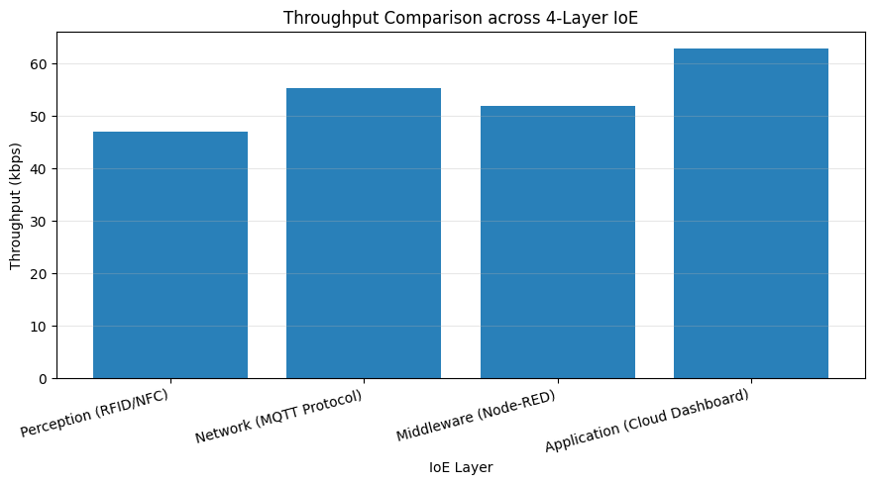
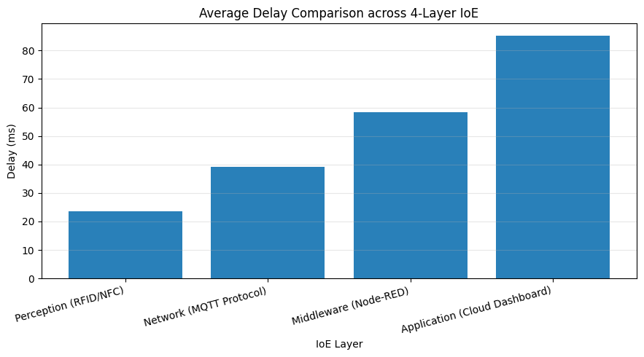
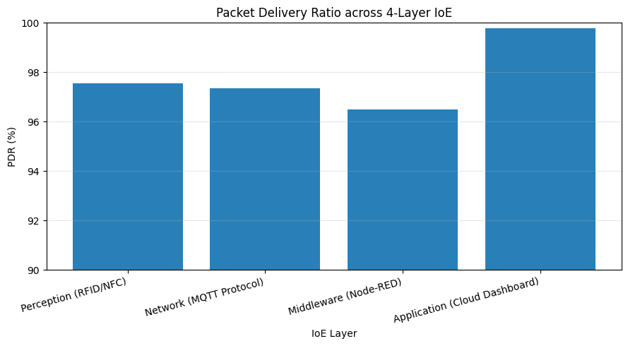
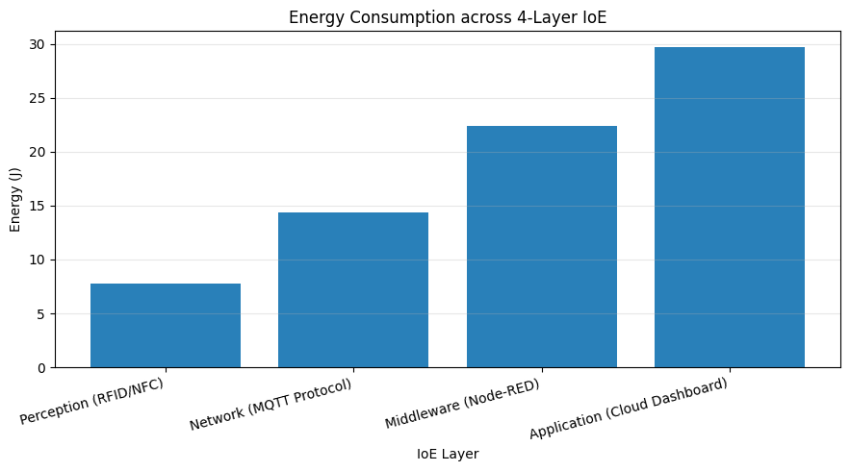
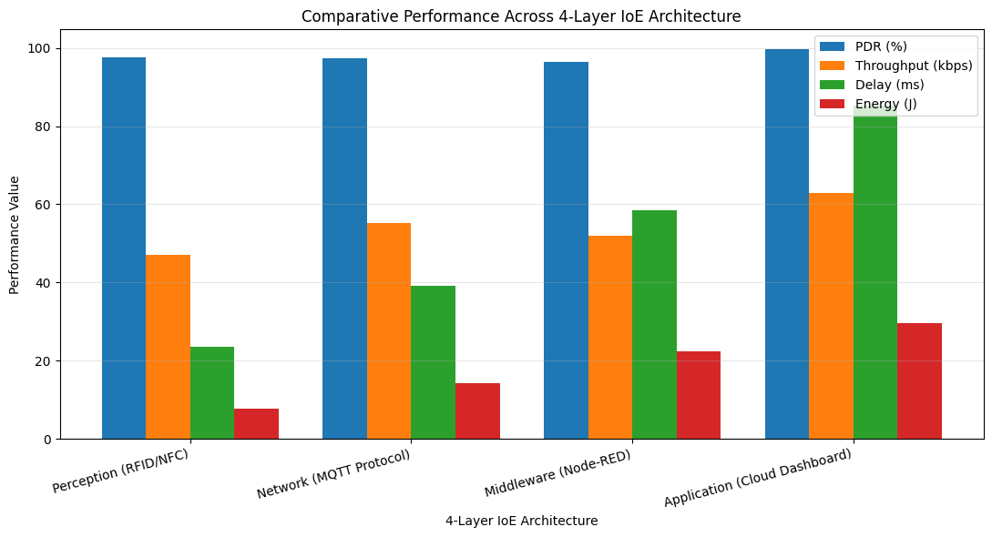

CONCLUSION
1. RFID/NFC successfully authenticates and identifies physical devices at the Perception layer.
2. MQTT messages and Node-RED flows efficiently bridge Network and Middleware data routing.
3. Grafana/Cloud dashboard successfully visualizes aggregated telemetry at the Application layer.

